Name:
Professor:
Course:
Date:
BCLN PHYSICS 12
Electromagnetism
- The phenomenon of magnetism was first investigated using scientific methods between 1540 – 1603 by Englishman William Gilbert. His discoveries led him to learn that the earth itself is a weak magnet. Between 1777 – 1851, Hans Christian Oersted suggested the link between electricity and magnetism. The discovery of magnetite (lodestones of magnetic stones), which form through volcanic activity.
- Rules (1) the direction of magnetic field is tangent to the field line at any point in space (2). The strength of a field is proportional to the closeness of the lines (3). The field lined move from north pole to south pole.
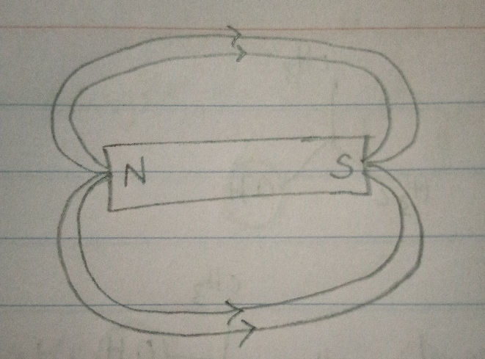
- When using a compass for navigation, it works because the earth itself is a magnet. Thus, the needle of the compass aligns with the earth’s magnetic field direction and points to the north – south direction.
Magnetic Fields
- A force field is a vector field describing a non-contact force acting on a particle at different points in space.
- Phenomena that have force fields are gravity and electrical fields.
Gravity = g = Gm₁/ r² – the gravitational field strength is directly proportional to the mas creating the field and inversely proportional to the square of the distance.
Electrical field = kQ/ r² – the point charge is affected by a charge magnitude Q, at a point distance r away.
- Permanent magnets are objects made from materials that are magnetized and are capable of creating their persistent magnetic fields, while electromagnets are magnets made from a coil of wire which acts as a magnet when an electrical current is passed through it. Example of permanent magnet is nickel and example of an electromagnet is solenoid wounded across a nail and connected to a magnet.
- Magnetic fields in an electromagnet and a bar magnet are similar because magnetic field lines move from the north to the south pole because of the force generated by aligned atoms.
- 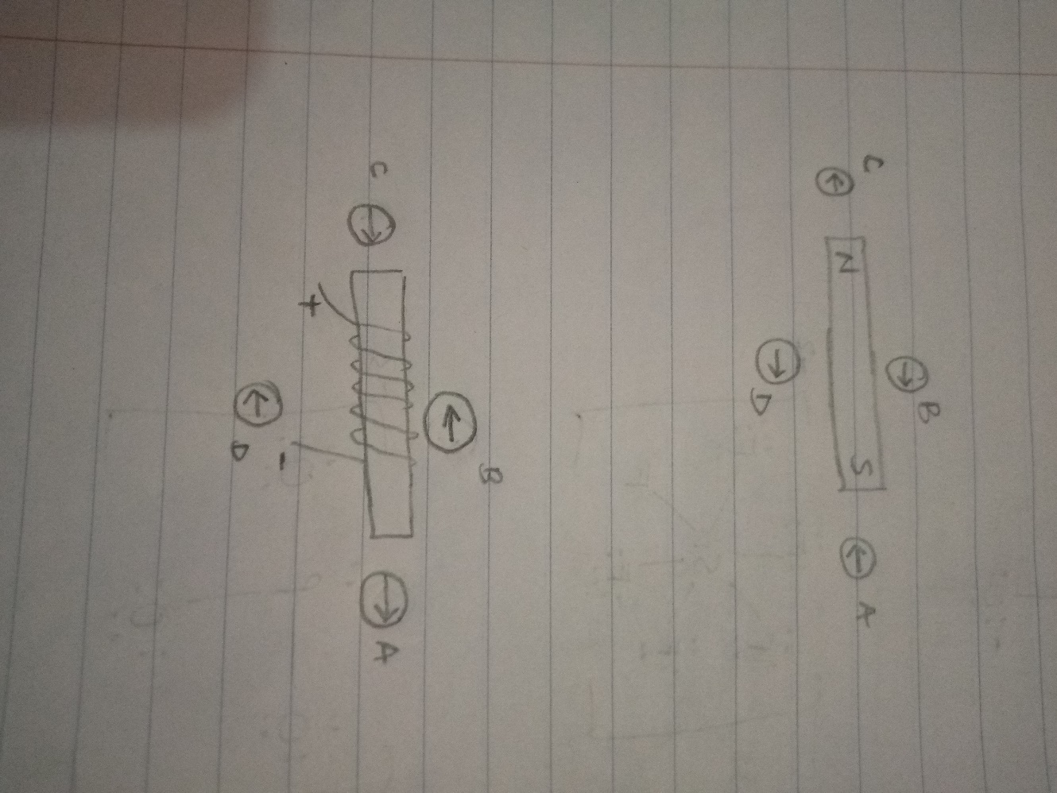
Diagram 1

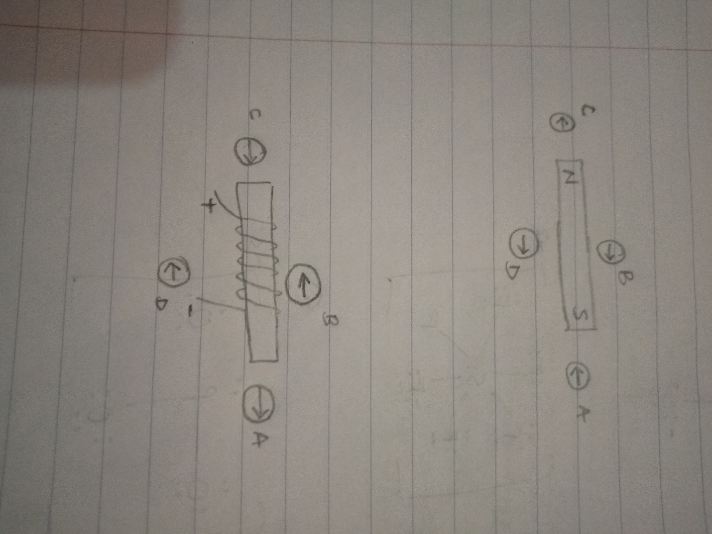
Diagram 2
- 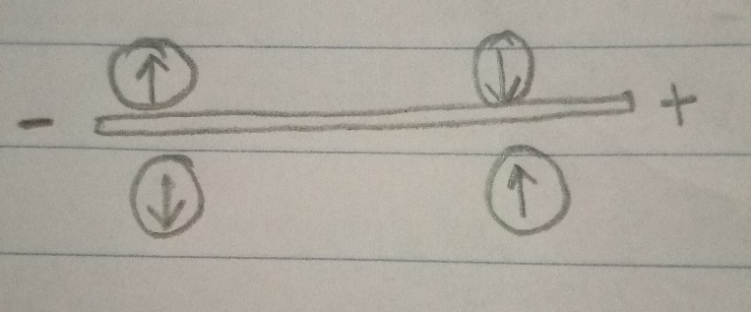
Diagram 1
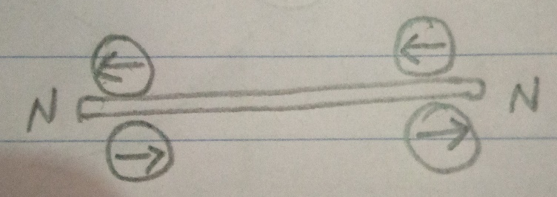
Diagram 2
- The right-hand rule states that to determine the direction of a magnetic force of a positive moving charge, point the right thumb in the direction of velocity (v), the index finger in the direction of the magnetic field (B), and the middle finger point the direction of the resulting magnetic force (F).
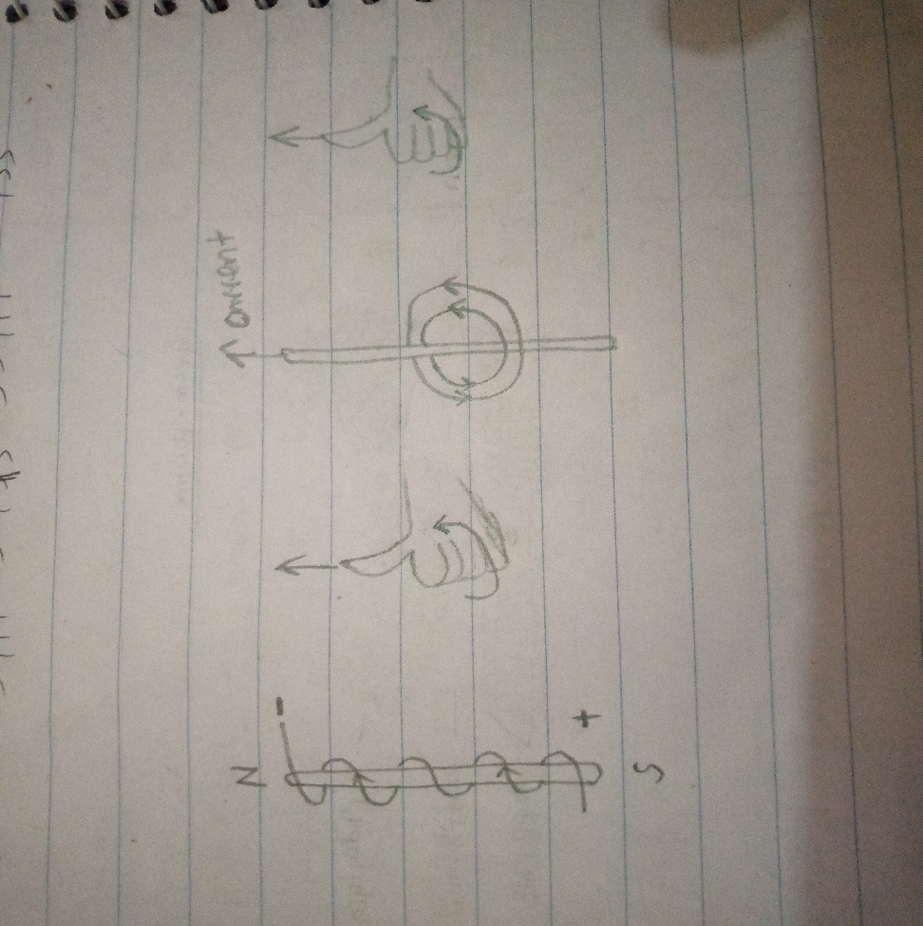
- 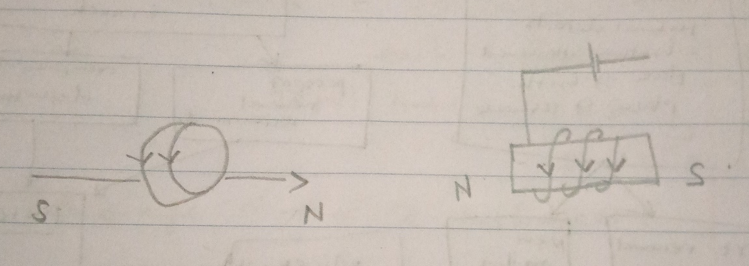
- 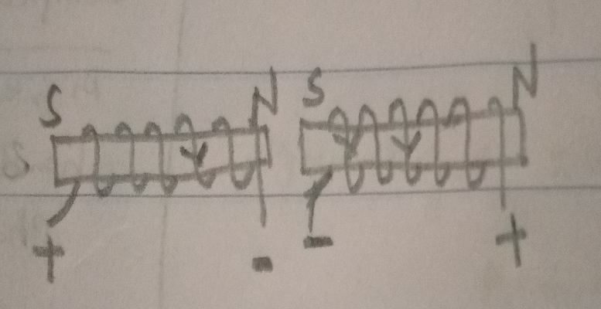
Diagram 1 – attract
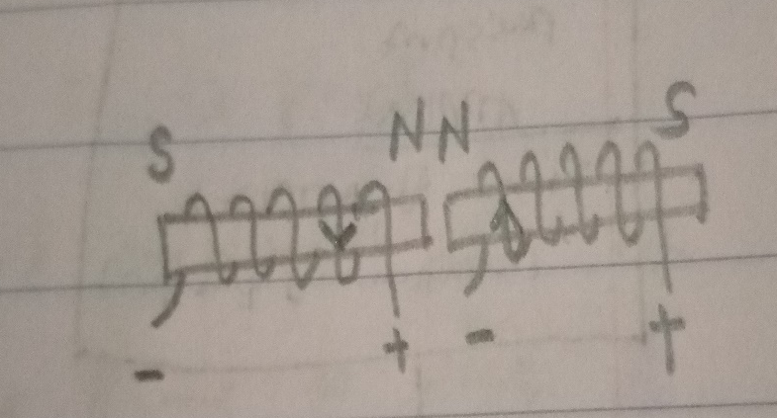
Diagram 2 – repel
- Something that people sometimes find confusing about the RHR is deciding which way to point their thumb. If the electrons are going in one direction, the current is in the ____opposite_________________direction. If it’s a positive charge that’s moving (less common, but possible), then the current goes in the ______same____________ direction
- μ_{o} = 4π x 10-7 Tm/A)
B = μ_{o} l (2πd)
= 4π x 10⁻⁷ × 24 (2 × 3.14 × 2) = 0.00024
B = 2.4 × 10⁻⁴ T
- (2.4 × 10⁻⁴) ÷ 4 = 0.00006 = 6 × 10⁻⁵
- B = 𝜇o𝑁𝐼/𝐿 = (4π x 10⁻⁷ × 600 × 5) ÷ 15
= 0.00025T = 2.5 × 10⁻²
- 600 ÷ 10 = 60 times
B = (2.5 × 10⁻²) ÷ 4 = 6.25 × 10⁻³
- N represents the number of turns and n represents the number of turns per unit length.
Increasing L decreases B.
- B = (4π x 10⁻⁷ × 400 × 2) ÷ 10 = 0.0001T
B = 4π x 10⁻⁷ × 40 × 2 = 0.0001T
Magnetic Forces
- Moving
- Electrical field; magnetic field. Electrostatic deflection occurs when an electric field is used to modify the path of a beam of charged particles. The electric field is applied traverse to the path of the charged particles. Deflection using a magnetic field occurs when a charged particle moves through a magnetic field and is deflected at a right angle to the magnetic field and direction of the particle.
- The right-hand rule states that to determine the direction of a magnetic force of a positive moving charge, point the right thumb in the direction of velocity (v), the index finger in the direction of the magnetic field (B), and the middle finger point the direction of the resulting magnetic force (F).
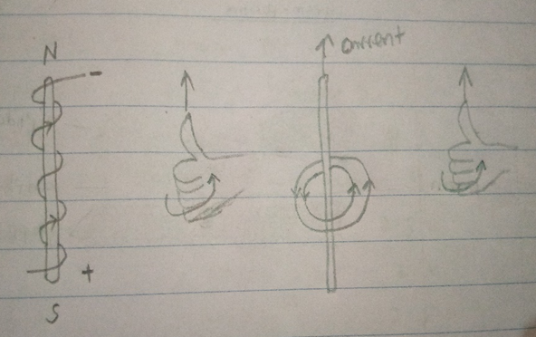
- The wire will bend into the page
- The direction of the force is upwards
- The electron will be deflected out of the plate
- The direction of the force is upwards
- The force acting on the electron is
F = k (q1q2/r²)
F = 8.98755 × 10⁹ ((1.60217 × 10⁻¹⁹ × 1.60217 × 10⁻¹⁹)) =
(3.5 × 10⁻²⁹)/ 1.21 × 10⁻¹⁷
F = 2.9 × 10⁻¹²
- F = qvB= ILB
5 × 0.05 × 12 = 3
3.0N
- F = ILB
50 × 0.12 × 0.9 =
5.4N into page
- F = ILB
= 100 × 0.01 × 1.73
1.73N into page
- B = F/qv
1.5 × 0.053 = 0.0795
0.0795/ 0.5 = 0.159
= 0.159T
- When one of the magnets is attached to a thin membrane, the changing magnetic field makes the membrane to vibrate, which in turn, vibrates air molecules.
- The force will be moving out of the page.
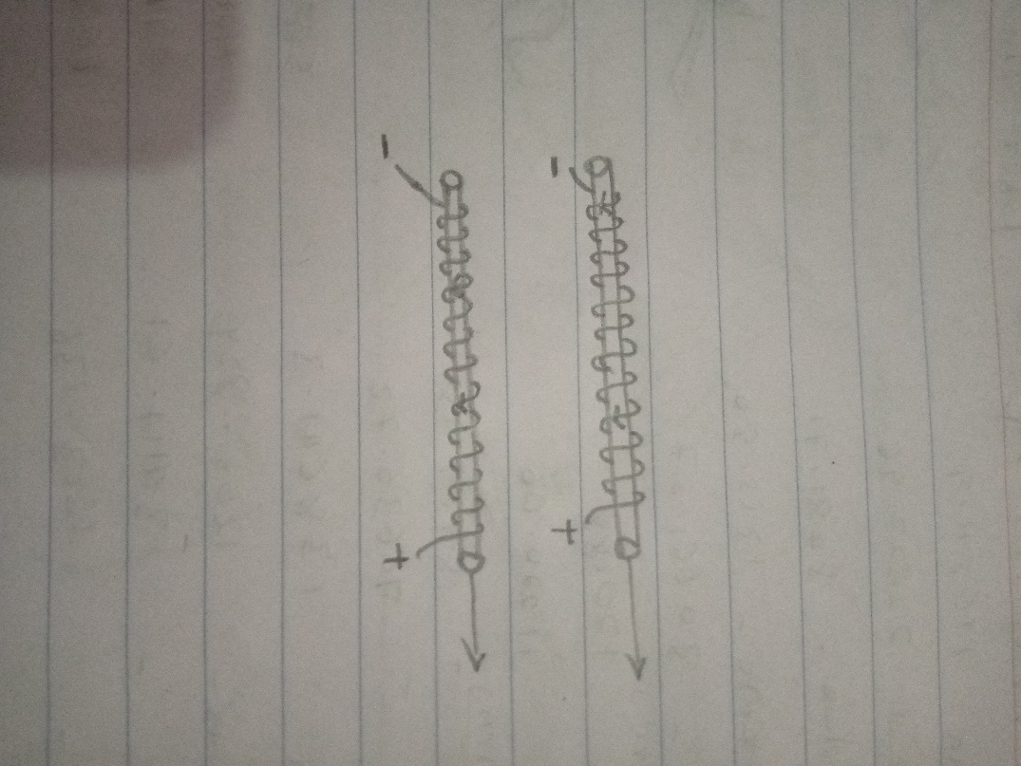
- The force is moving down in figure 1
Force is moving up in figure 2
The proton will be deflected out
The poles are S, N, S, N
- The beam is parallel to the magnetic field.
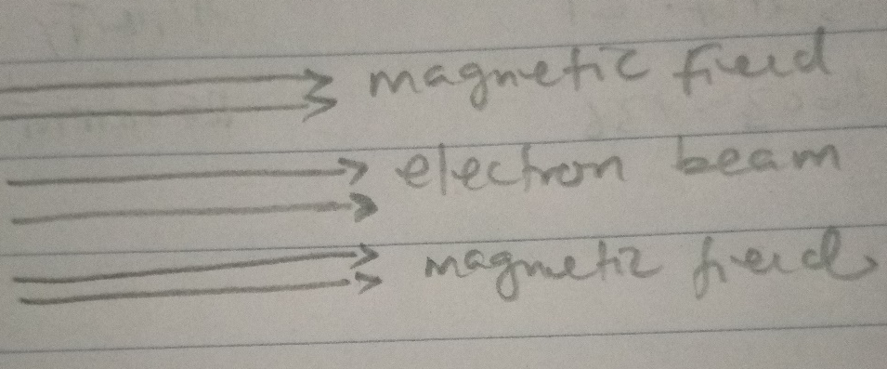
- Because it is perpendicular to the force
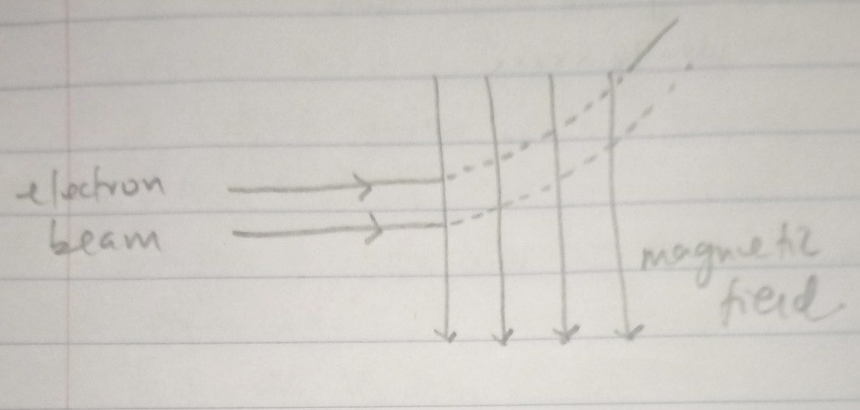
- The force will move as shown
a – up
b – up
c – down
d – out
e – out
f – in
- When the current flows, the pivoted wire will move as shown
a – right
b –right
c – left
- F = qvB
I = q/t ; q = tl
V = L/t
F = (tl)(L/t)B = ILB
- F – force, B – magnetic field, q – charge, v – velocity. Force is perpendicular
F – force, B – magnetic field, I – current, L – length. Force is perpendicular
- F = qvB Magnitude of force is 1.25 × 10⁻¹³N
- Magnitude of force =F = ILB = 30 × 0.96 × 0.9 = 2.8
2.8N
- a. Velocity v = F/qB = (1.0 × 10⁵) ÷ 0.40 =
2.5 × 10⁵m/s
b. Electric field = q = F/vB = (3.0 × 10⁵) ÷ 0.5 =
1.5 × 10⁵N/C
c. magnitude of force = B = F/qv = (4.0 × 10⁵) ÷ (8.0 × 10⁵) =
0.5T
d. Doubling the mass will lead to a lack of charge. F_{E} = mg
QE = mg
M = QE/g
Mass Spectrometer
- Moving charges generate their own magnetic field.
- The magnetic force on a charged particle is always ____perpendicular_____________ to the velocity of the particle. This creates a situation like a car moving in a circular track, where the friction force pushes the car towards the ______center______________of the circle.
- A way to make the circular motion of the particle tighter (smaller circle) is to ___increase_____________the magnetic field.
- Speed of proton = B = μI/2πr
B = F/qv
V = 1.3 x 105 m/s
- The radius will remain the same
- The electric field = E = V/d = 6.5 x 10⁵ V/m
Voltage = V = Ed = 3.3 x 103 V
- Speed of electrons = E = V/d; V = Ed = 2.0 x 10⁶ m/s
The radius = r = μI/ 2πB = 3.8mm
- a – the proton will circle down in the clockwise direction
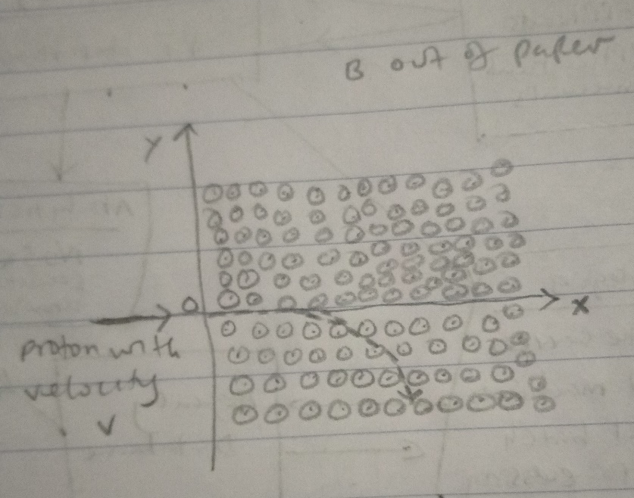
b – radius of the path r = μI/ 2πB = 7.2 cm
- Radius of the path is r = mv/qB = mE_{s}/ qBB_{S}
r = (2.18x10-26 × 950) ÷ 0.93² = 2.39 × 10⁻²³
- Direction of electric field is up
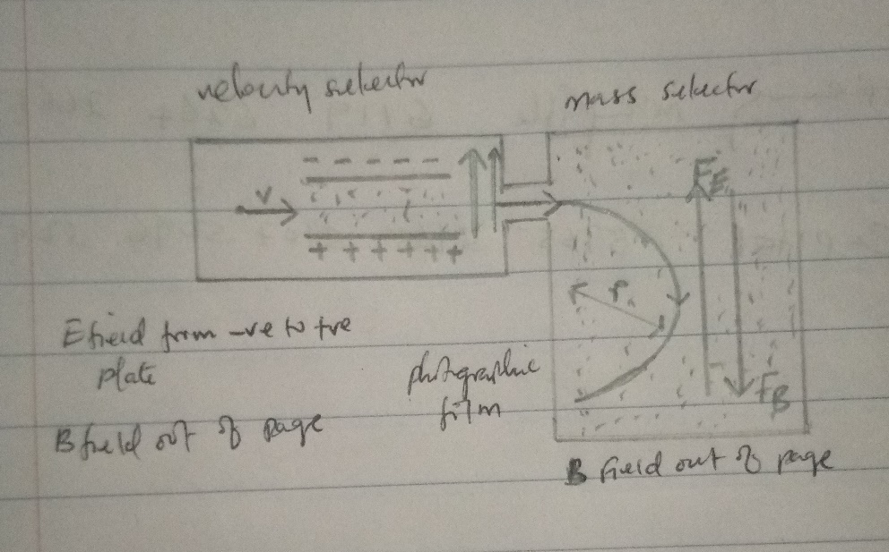
- Direction of magnetic force is F_{B}– downward; F_{E} – upward
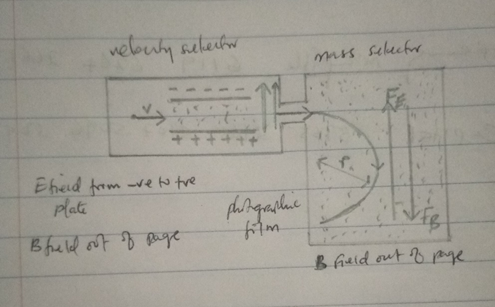
- For the charge to remain moving in a straight path, F_{B} = F_{E} , v = E/B
- If it was a negatively charged ion, F_{b} would go down and F_{E} goes up.
- Velocity = v = qBr/m = 1022m/s
- The magnetic force is perpendicular to the speed of the ions.
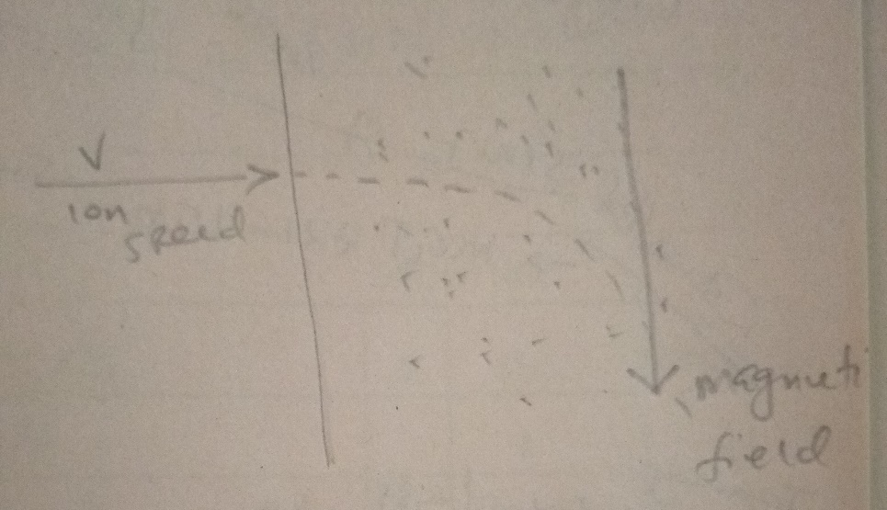
- Equation of motion for ion is m(dv/dt) = q(E + v × B)
r = mv/qB = mE_{s}/ qBB_{S} = 0.00015m
- Doubling the mass and tripling the charge would reduce the radius by 2/3
r = mvqB
2/3r = 2mv3qB

